**Lab Tasks**

Task-1: Using Tailwindcss perform following Tasks

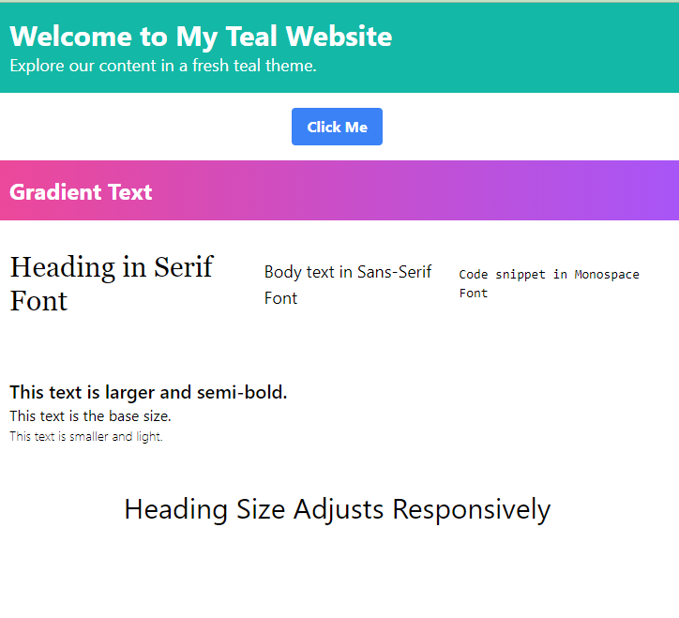Task-II

Perform The following.

* Create a basic Registration form!
* The input border should change color to red when it is focused.
* The form not be visible in screen below medium and below devices instead it will show kindly change the device to see the form.
* Button color should be black and text white on hover color will change to Green and white
* Form Background and text color should change when the screen size change

Task-III : create this table using Tailwindcss

Task-IV

* Colorful Unordered List: Craft an unordered list with custom bullet colors (e.g., red, teal) and contrasting text for easy reading.
* Numbered Ordered List: Build an ordered list with custom starting numbers (e.g., list-decimal-5) and explore alternative numbering styles (e.g., roman, lower-roman).
* Indented Nested Lists: Create nested lists with proper indentation using classes like ml-4 and style nested items differently for clarity.
* Iconic Description List: Combine the dl element with icons for terms, customize their colors and sizes, and add clear definitions using dd.
* Horizontal List with Spacing: Construct a horizontal list using flex, space items with mr-4/ml-4, and style them as buttons or links for interactivity.

Task-V

* Do the following  
  Responsive Image Gallery:
* Maintain the original grid layout and image classes for the Image gallery.
* Consider using media queries to adjust h-48 sm:h-64 md:h-80 for different screen sizes, though it won't offer the same dynamic resizing as in the original code.
* 2. Product Image with Zoom on Hover:
* Use CSS transformations (e.g., hover: scale-110) and transitions (e.g., transition duration-200) to achieve a basic zoom effect without JavaScript.

**Task-VI**

Do the following using tailwindcss only

Considering you have 6 images change the default grid breakpoints in such way that.

* On 332px and below it will show image1 and hider others
* On 632px and below it will show image2 one and hider others
* On 832px and below it will show image3 one and hider others
* On 1032px and below it will show image4 one and hider others
* On 1232px and below it will show image5 one and hider others
* On 1432px and below it will show image6 one and hider others

**Task-VII**

Do the following using tailwinds only

Create a form and Table and form side by side such that

* in large and above screens it shows form in 60% of area and table in 30% .
* on a Small Screen it shows the form both on 100% of the screen with different backgrounds and colors

**Task-VII**

Create the following using tailwind csss

**Task- IX**

Create the following using tailwindcss

**Task-X**

Other Task will be added by Sunday